Lip Volume Velocity of Synthetic Speech

# Linear Model of Speech Production

The linear model for speech production describes a speech signal as the output of a linear system which, for voiced speech (vowels), is excited by an impulse train input. The impulse train signal $x[n]$ is amplified by a scale factor $g$, which depends on the intensity, or loudness, of the speech. The signal then passes through the glottal filter $G(z)$ to produce the glottal volume velocity $u_{G}[n]$. The glottal filter is a critically damped second order low pass filter with one repeated real pole,

|  |  |
| --- | --- |
| $$G\left(z\right)=\frac{1}{{\left(1-e^{-ω_{c}T}z^{-1}\right)}^{2}},$$ | (1) |

where $ω_{c}$ is the cutoff frequency in rad/s and $T$ is the sampling period.

The glottal volume velocity $u_{G}[n]$ then passes through the vocal tract filter $V(z)$ to produce the lip volume velocity $u_{L}[n]$. The vocal tract can be modelled as a cascade of overdamped second order low pass filters, where each filter resonates at a particular formant frequency,

|  |  |
| --- | --- |
| $$V\left(z\right)=\frac{1}{\prod_{i=1}^{N}{\left(1-2e^{-πB_{i}T}\cos\left(2πF_{i}T\right)z^{-1}+e^{-2πB_{i}T}z^{-2}\right)}},$$ | (2) |

where $K$ is the maximum number of formants that can be captured by the model, $F_{i}$ is the $i$-th formant frequency and $B_{i}$ is the 3dB bandwidth of the $i$-th formant.

The lip volume velocity $u_{L}[n]$ then passes through the lip radiation filter $L(z)$ to produce the speech signal $s[n]$. The effect of lip radiation is a 6dB/octave lift in the spectrum of the signal, which can be modelled as a first order differentiator,

|  |  |
| --- | --- |
| $$L\left(z\right)=1-z^{-1}.$$ | (3) |

The spectrum of the resulting speech signal $s[n]$ is given by

|  |  |
| --- | --- |
| $$S\left(z\right)=gX\left(z\right)G\left(z\right)V\left(z\right)L\left(z\right)=gX\left(z\right)H(z).$$ | (4) |

where $H(z)$ is the transfer function of the entire speech production model, capturing the action of the glottis, vocal tract and lip radiation,

|  |  |
| --- | --- |
| $$H\left(z\right)=\frac{1-z^{-1}}{{\left(1-e^{-ω_{c}T}z^{-1}\right)}^{2}\prod_{i=1}^{N}{\left(1-2e^{-πB_{i}T}\cos\left(2πF_{i}T\right)z^{-1}+e^{-2πB_{i}T}z^{-2}\right)}}.$$ | (5) |

# Lip Volume Velocities

The lip volume velocity $u_{L}[n]$ can be obtained by taking the running total (integral) of the speech signal,

|  |  |
| --- | --- |
| $$u_{L}\left[n\right]=\sum_{m=0}^{n}{s[m]}=u_{L}\left[n-1\right]+s\left[n\right].$$ | (6) |

In the z-domain, integration can be described as a linear system with a pole at $z=1$,

|  |  |
| --- | --- |
| $$\frac{U_{L}\left(z\right)}{S\left(z\right)}=\frac{1}{1-z^{-1}}=\frac{1}{L\left(z\right)}.$$ | (7) |

The transfer function relating the lip volume velocity to the impulse train input is

|  |  |
| --- | --- |
| $$\frac{U_{L}\left(z\right)}{X\left(z\right)}=\frac{1}{{\left(1-e^{-ω_{c}T}z^{-1}\right)}^{2}\prod_{i=1}^{N}{\left(1-2e^{-πB_{i}T}\cos\left(2πF_{i}T\right)z^{-1}+e^{-2πB_{i}T}z^{-2}\right)}}$$ | (8) |

which is stable, since all poles lie within the unit circle. Note that the poles of the system are of the form

|  |  |
| --- | --- |
| $$z=e^{-ω_{c}T} , z=e^{-πB_{i}T}e^{±j2πF_{i}T}$$ | (9) |

This means that a bounded $x[n]$ produces a bounded $u_{L}[n]$, which is expected.

Synthetic speech tends to produce unbounded lip volume velocities, which indicates that it does not originate from the source-filter model. It is well known that integration is an unstable process, since the pole at $z=1$ lies on the unit circle in the z-plane. This means that a bounded input speech signal $s[n]$ can potentially produce an unbounded output lip volume velocity $u_{L}\left[n\right]$ when the integral is taken.

# Impact of the Microphone

When speech is recorded by the microphone, frequencies within 0 – 20Hz are not captured, thus the recorded speech has zero mean, resulting in a lip volume velocity which is also zero mean. The synthetic speech models appear to contain frequencies within the 0 – 20Hz range, causing a variable DC offset to the lip volume velocity. Note that, in the z-domain, the pole at $z=1$ causes a spike in the frequency response at DC,

|  |  |
| --- | --- |
|  | (10) |

which causes low frequencies to be amplified and high frequencies to be attenuated.

“The key you designed will fit the lock”

**Natural Speech - Male**

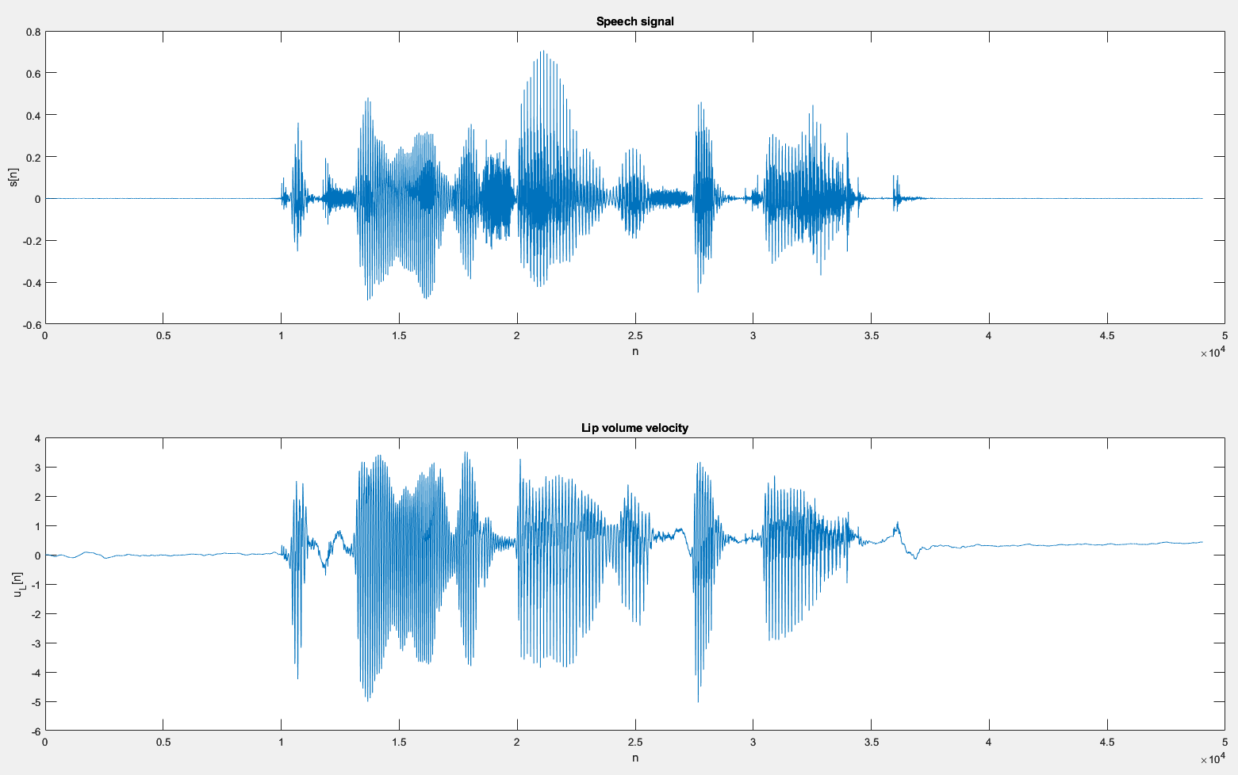

**Tacotron 2 – Male**

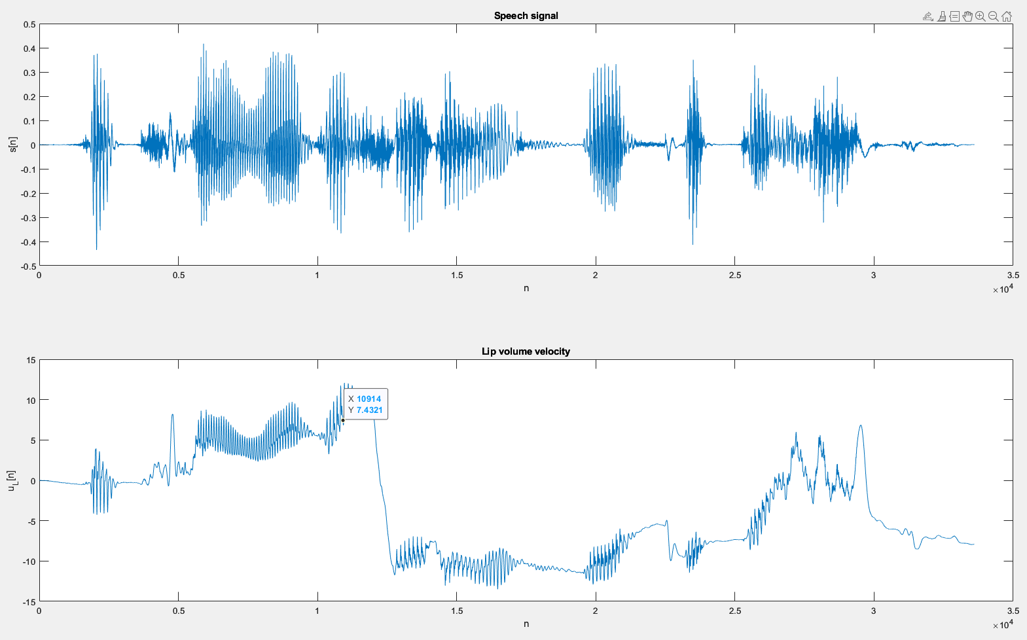

“The quick brown fox jumped over the lazy dog”

**MaryTTS - Male**

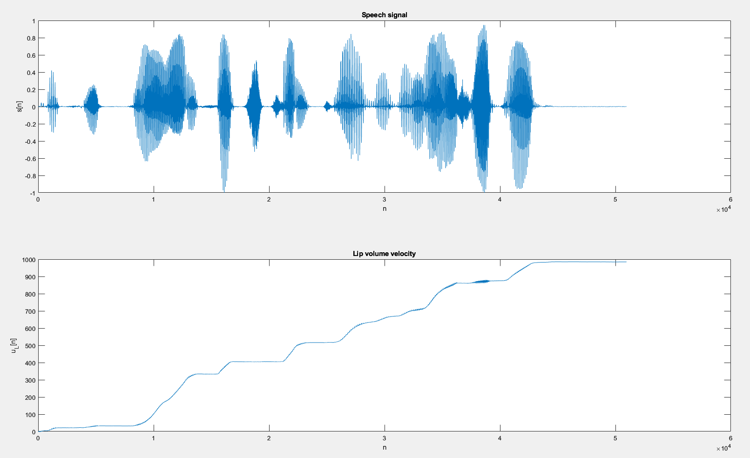

**Festival - Female**

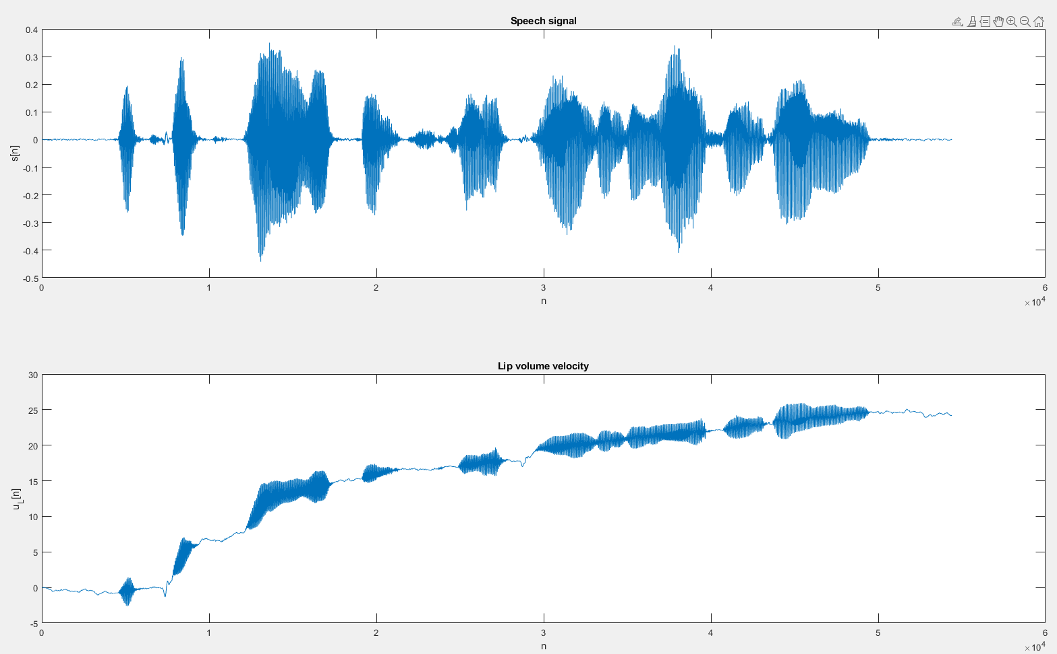

**FastSpeech2 - Female (American)**

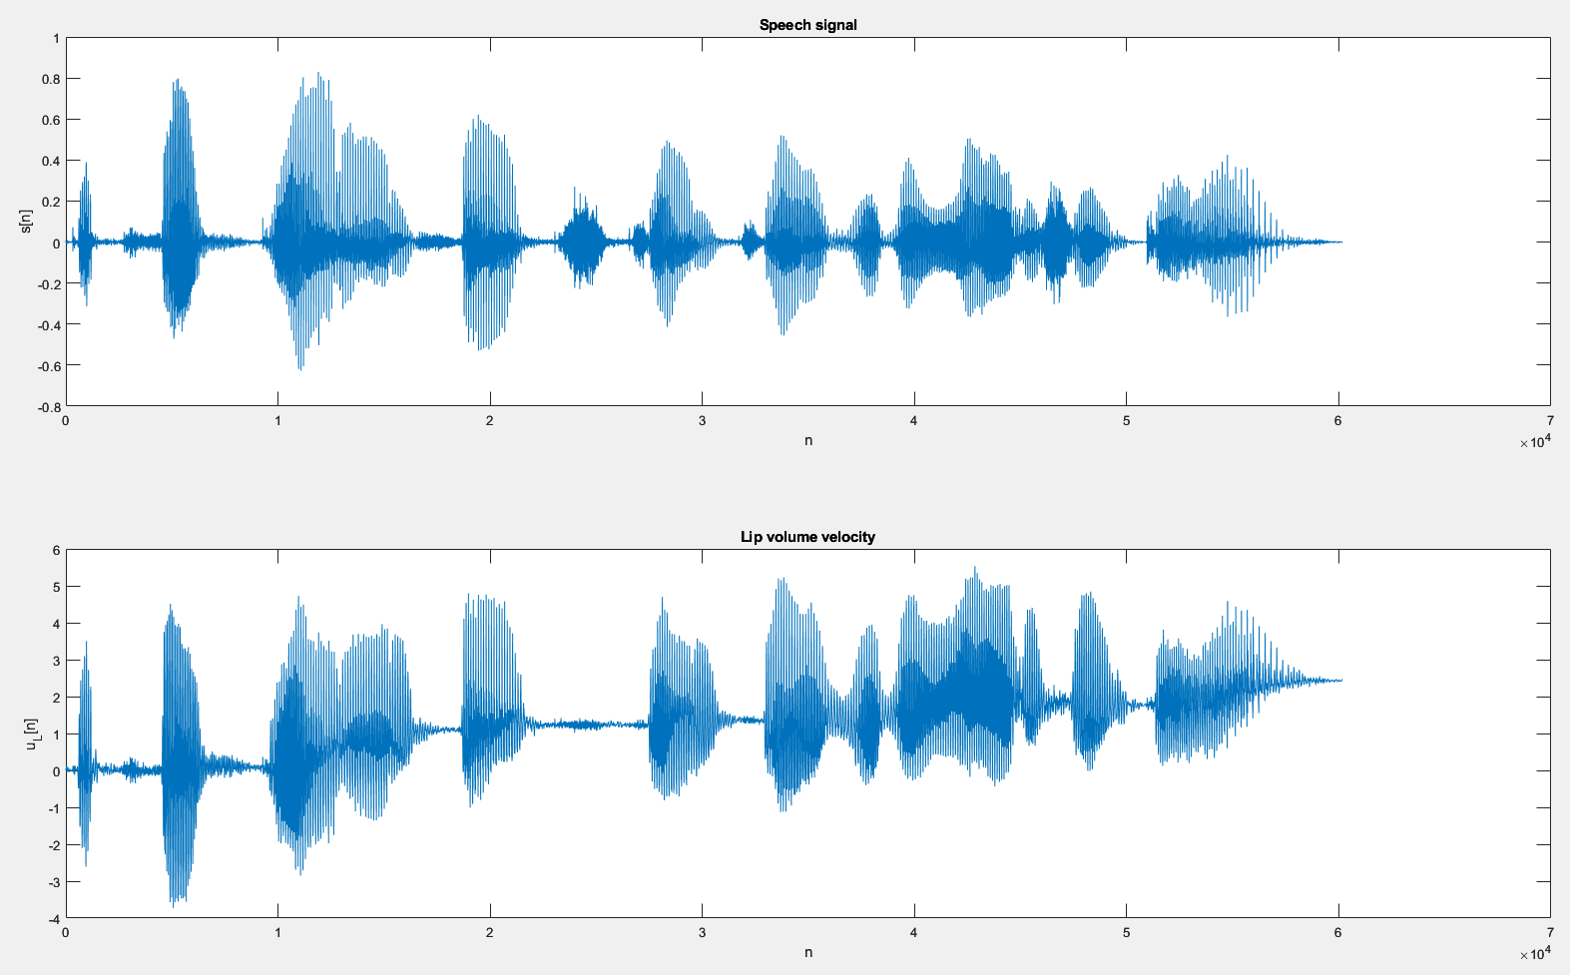

* Natural speech has a lip volume velocity which is approximately zero mean
* Tacotron 2 speech lip volume velocity mean value is seemingly random
* MaryTTS, Festival and Fastspeech2 have lip volume velocities which have increasing mean values. MaryTTS has the biggest increase, followed by Festival and then Fastspeech2.